1. **Agenda:**
   1. We are going to try if the producer acknowledgement feature works.
2. 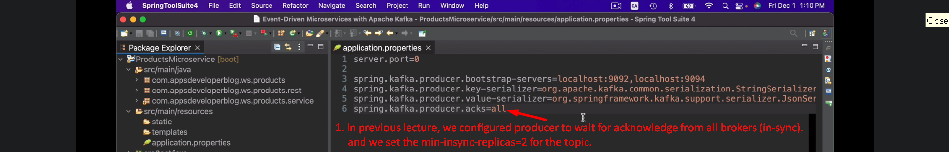
3. Min-insync-replicas=2 means that the producer will wait for two brokers (insync) to confirm that the msg was received.   
   If two in sync brokers don’t, then the write operation will not be successful and Kafka producer will throw an exception.
4. 
5. 
6. 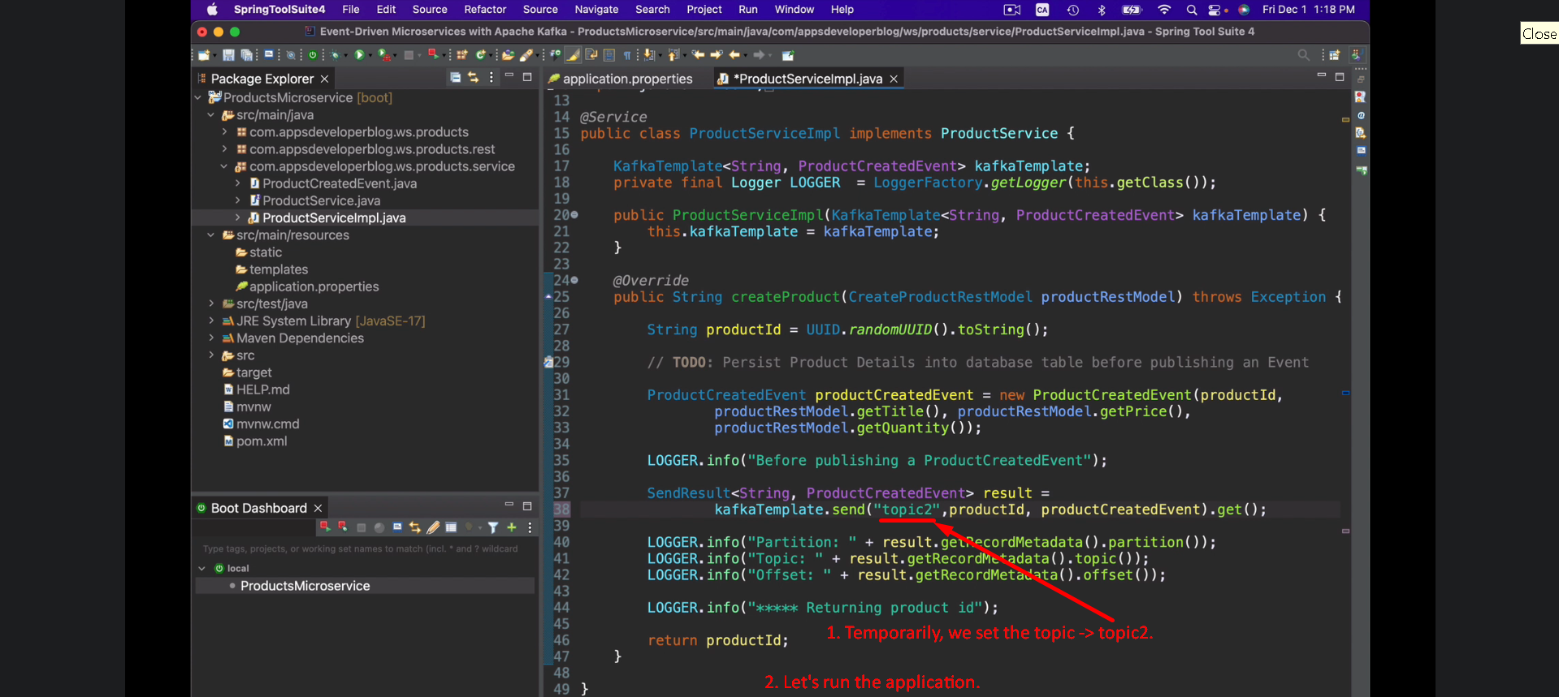  
   
7. 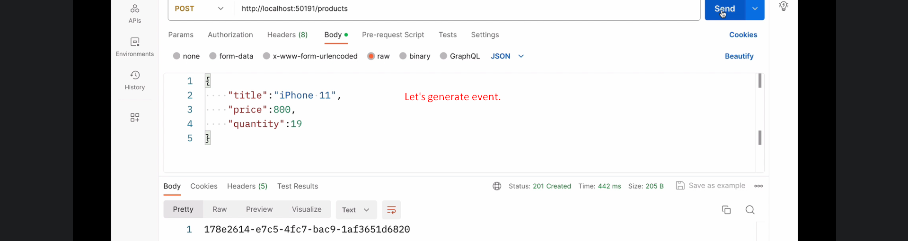
8. 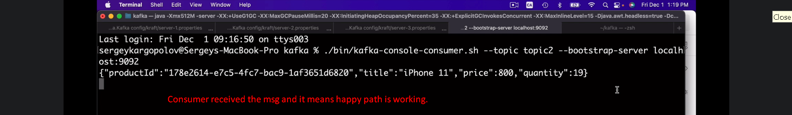
9. 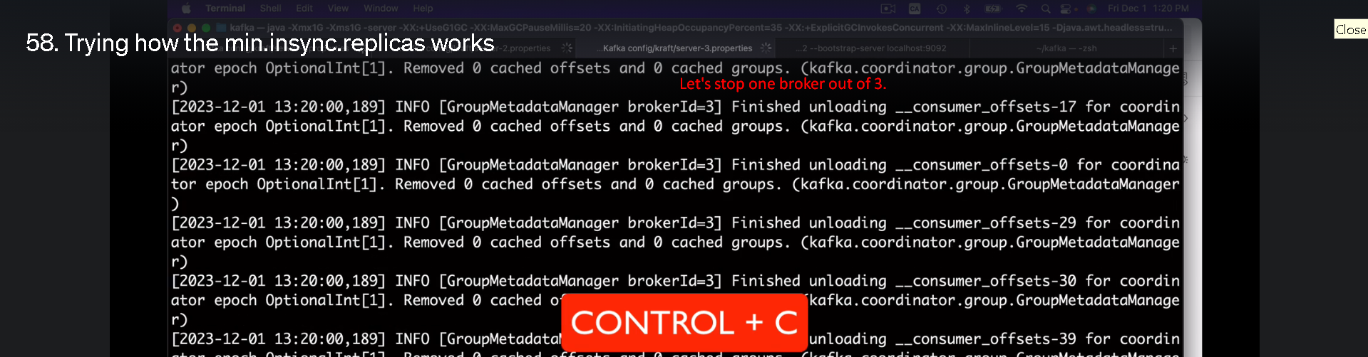
10. 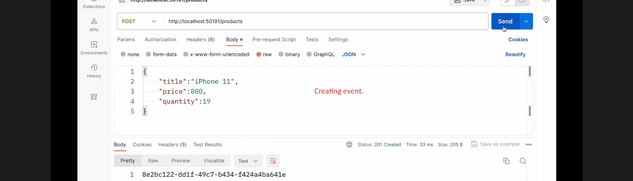
11. 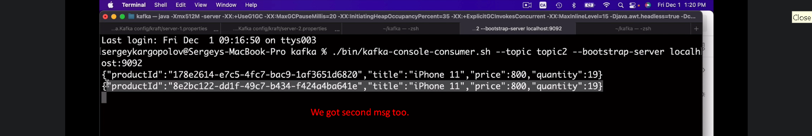
12. 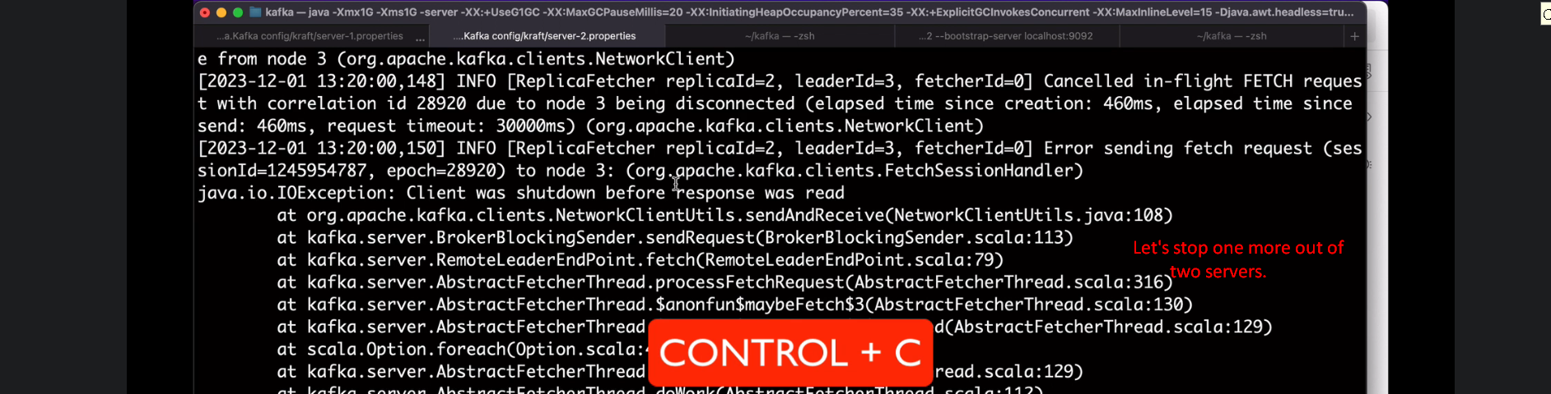
13. 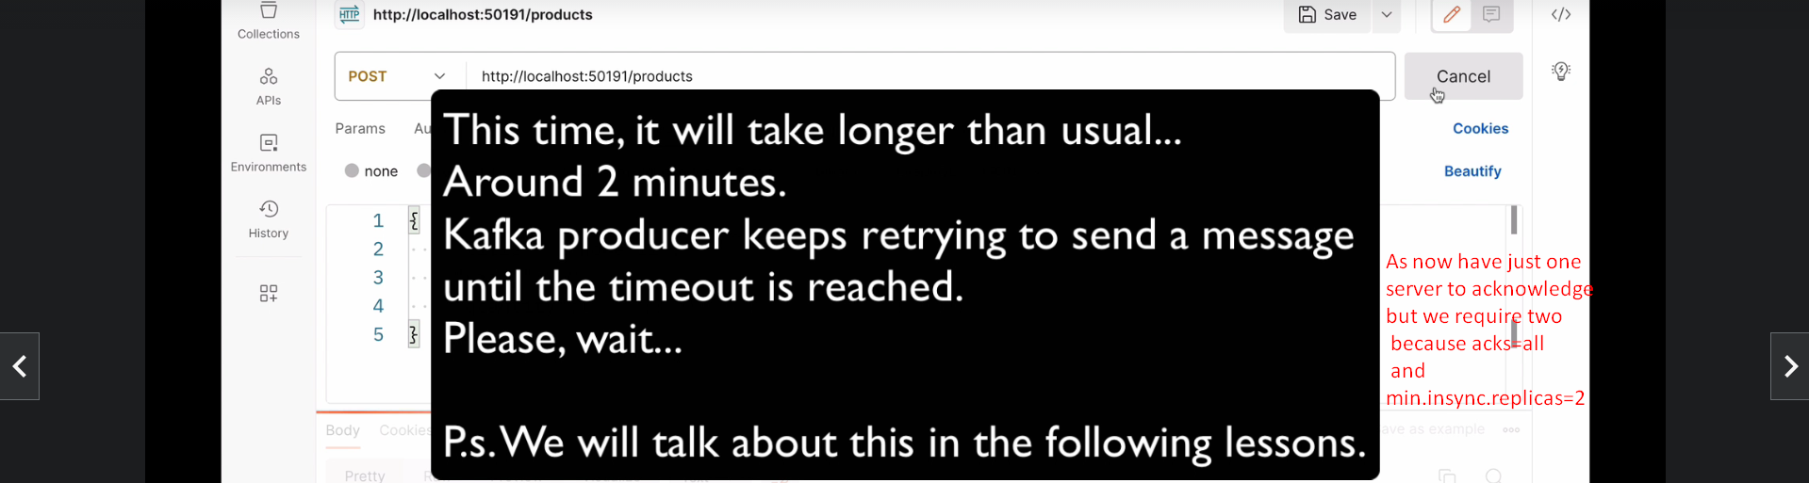  
      
    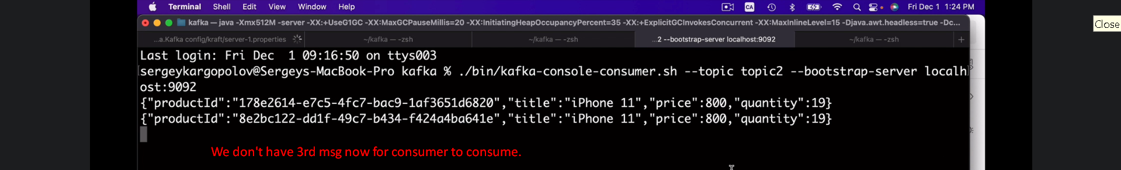
14. 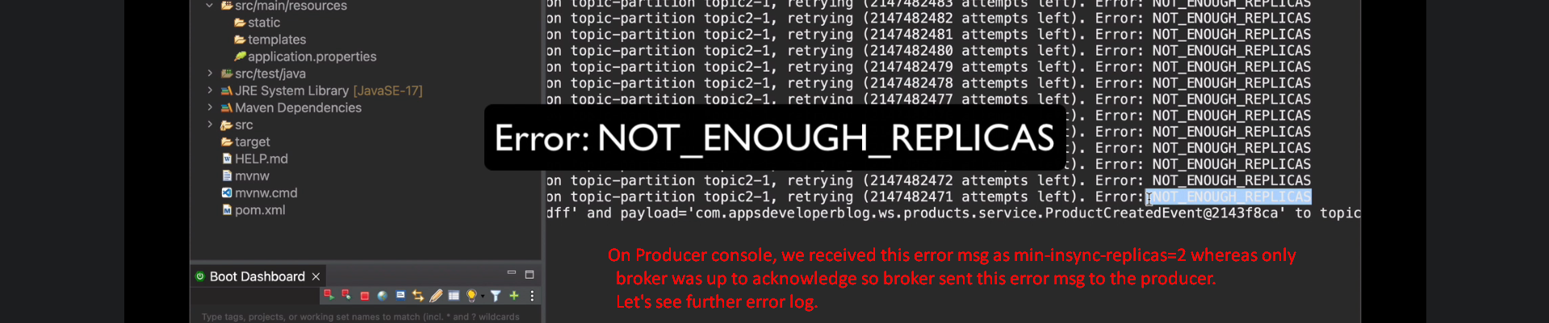  
      
    It means acks=all and min-insync-replicas=2 both are working fine.